### chatbot to shop for essentials during pandemic using Watson Assistant

Project Description

**Project Description:**

Today, because of social distancing and other issues it can be risky for some people to shop for essential items in person. This project helps with this issue by giving people an online option to shop for essentials. With the help of Watson assistant, a chatbot is built. This chat should have the following capabilities:

1. Give the list of items in the Store
2. Should show the  prices of vegetables
3. Display if there are any offers or discounts
4. The bot should be able to take details like name, contact number, address, and the items to place the order.

**Services Used:**

1. IBM Watson Assistant
2. Node-Red

**Architecture:**

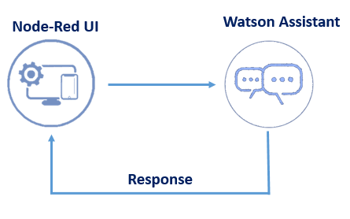

Screenshots

Create dialog for the project

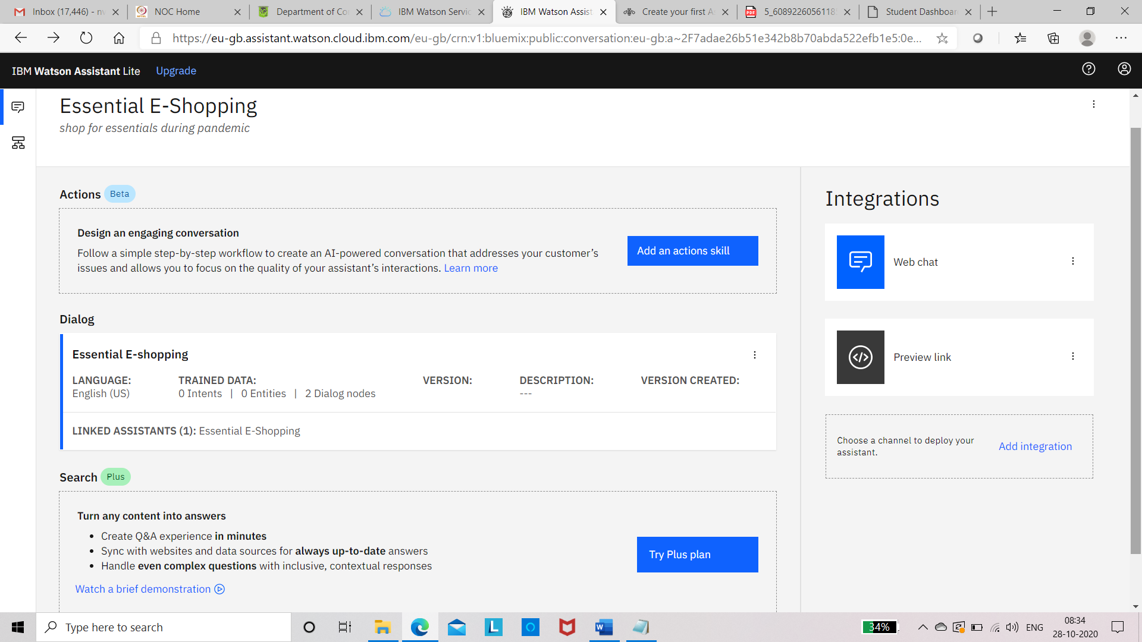

**Click on Essential E-shopping dialog and we will get following screen**

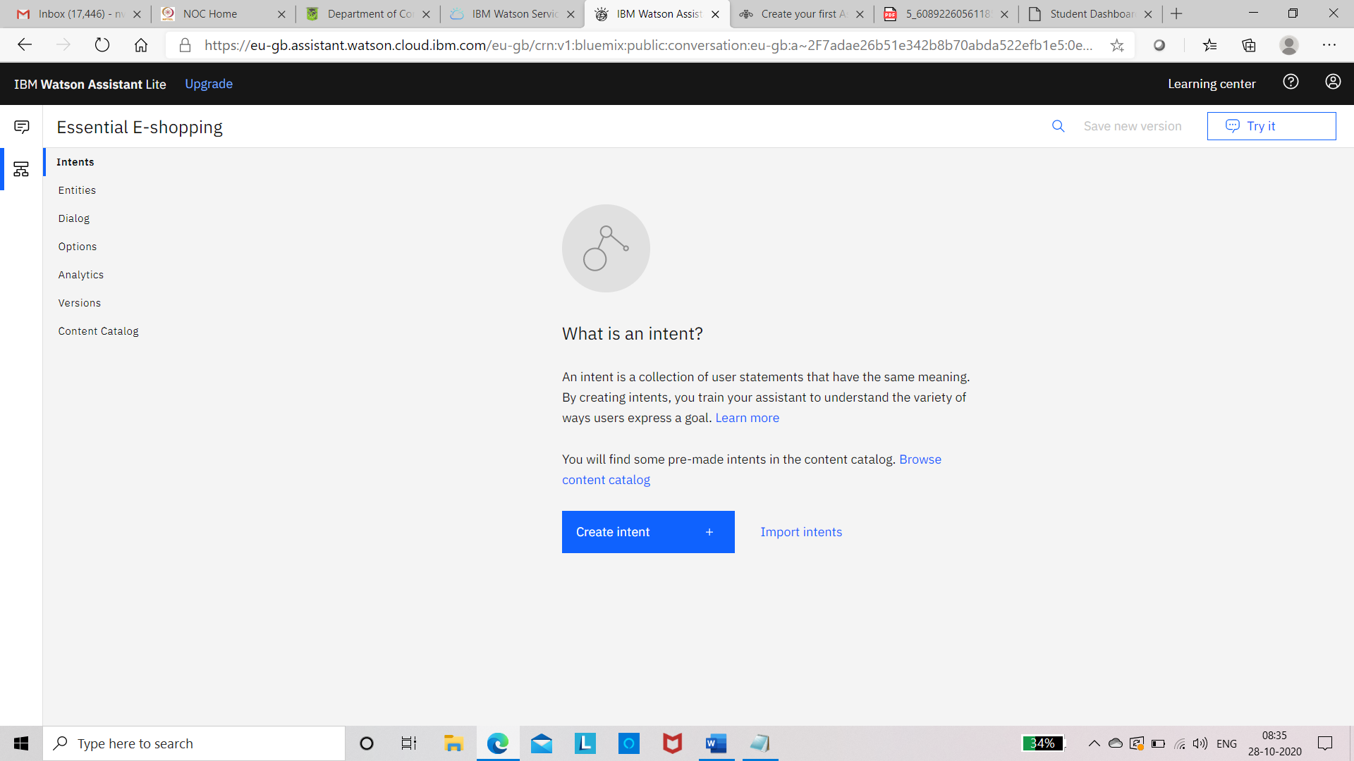

**Click on intent and create necessary intents**

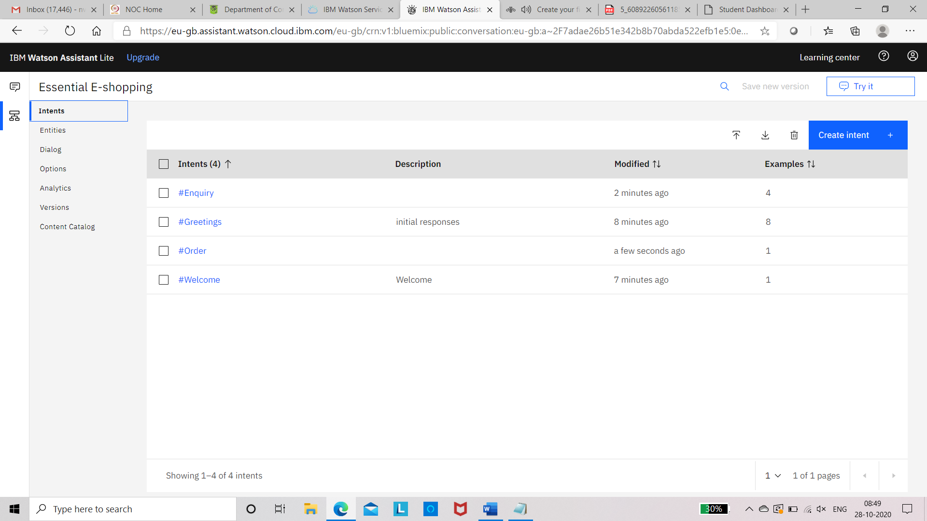

**Create entities**

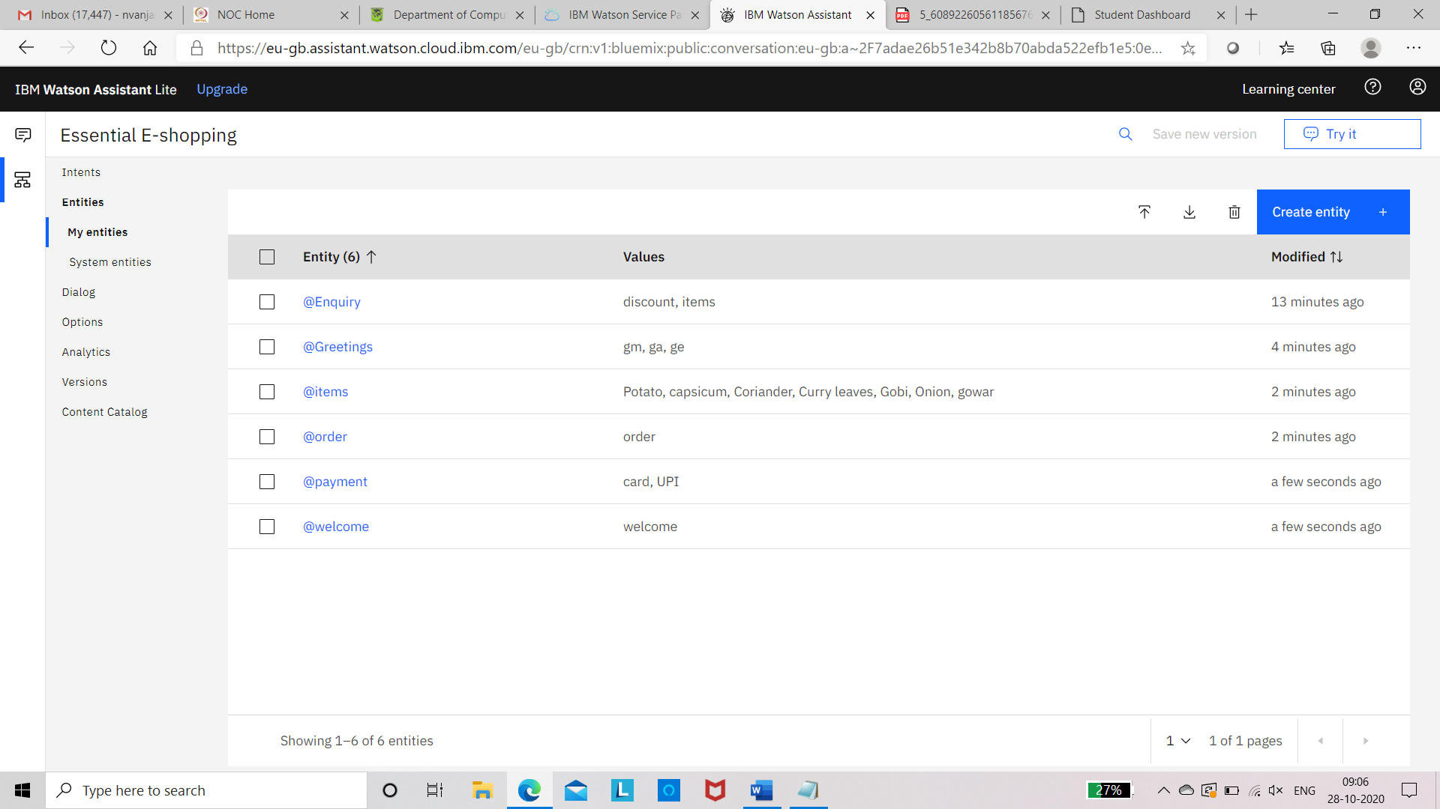 **System entities**

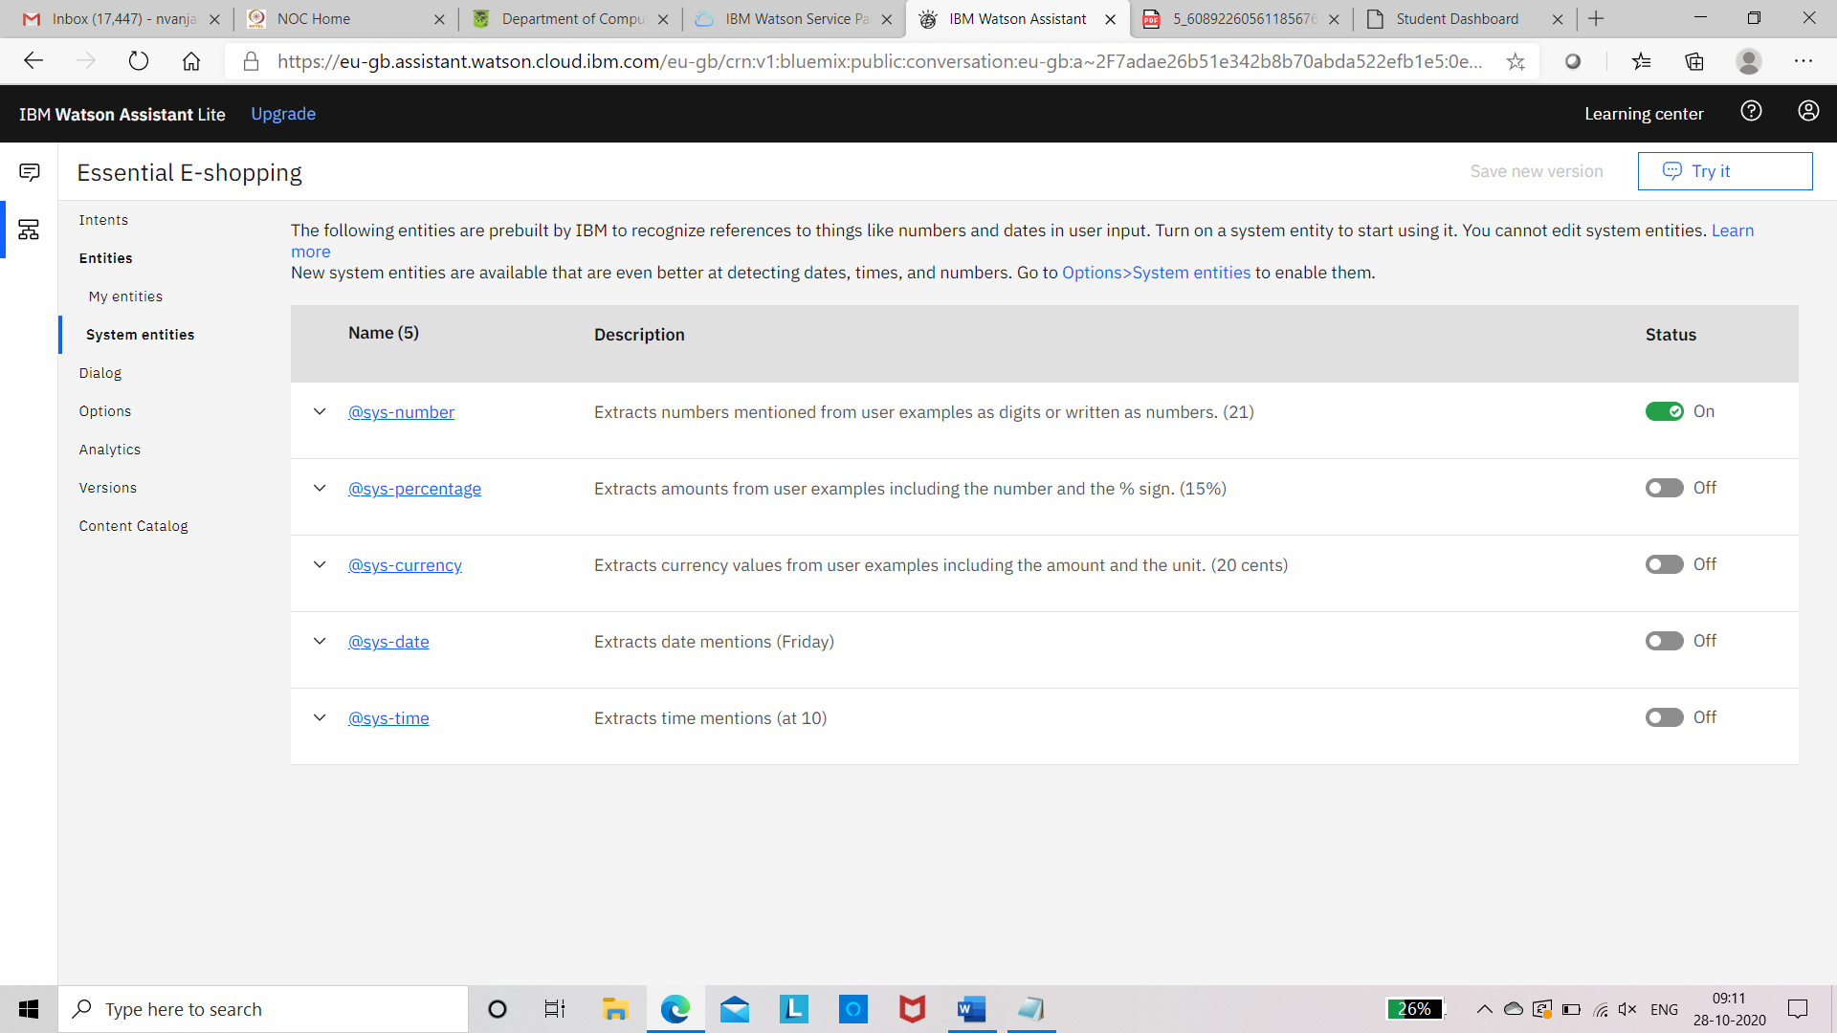

Dialogues

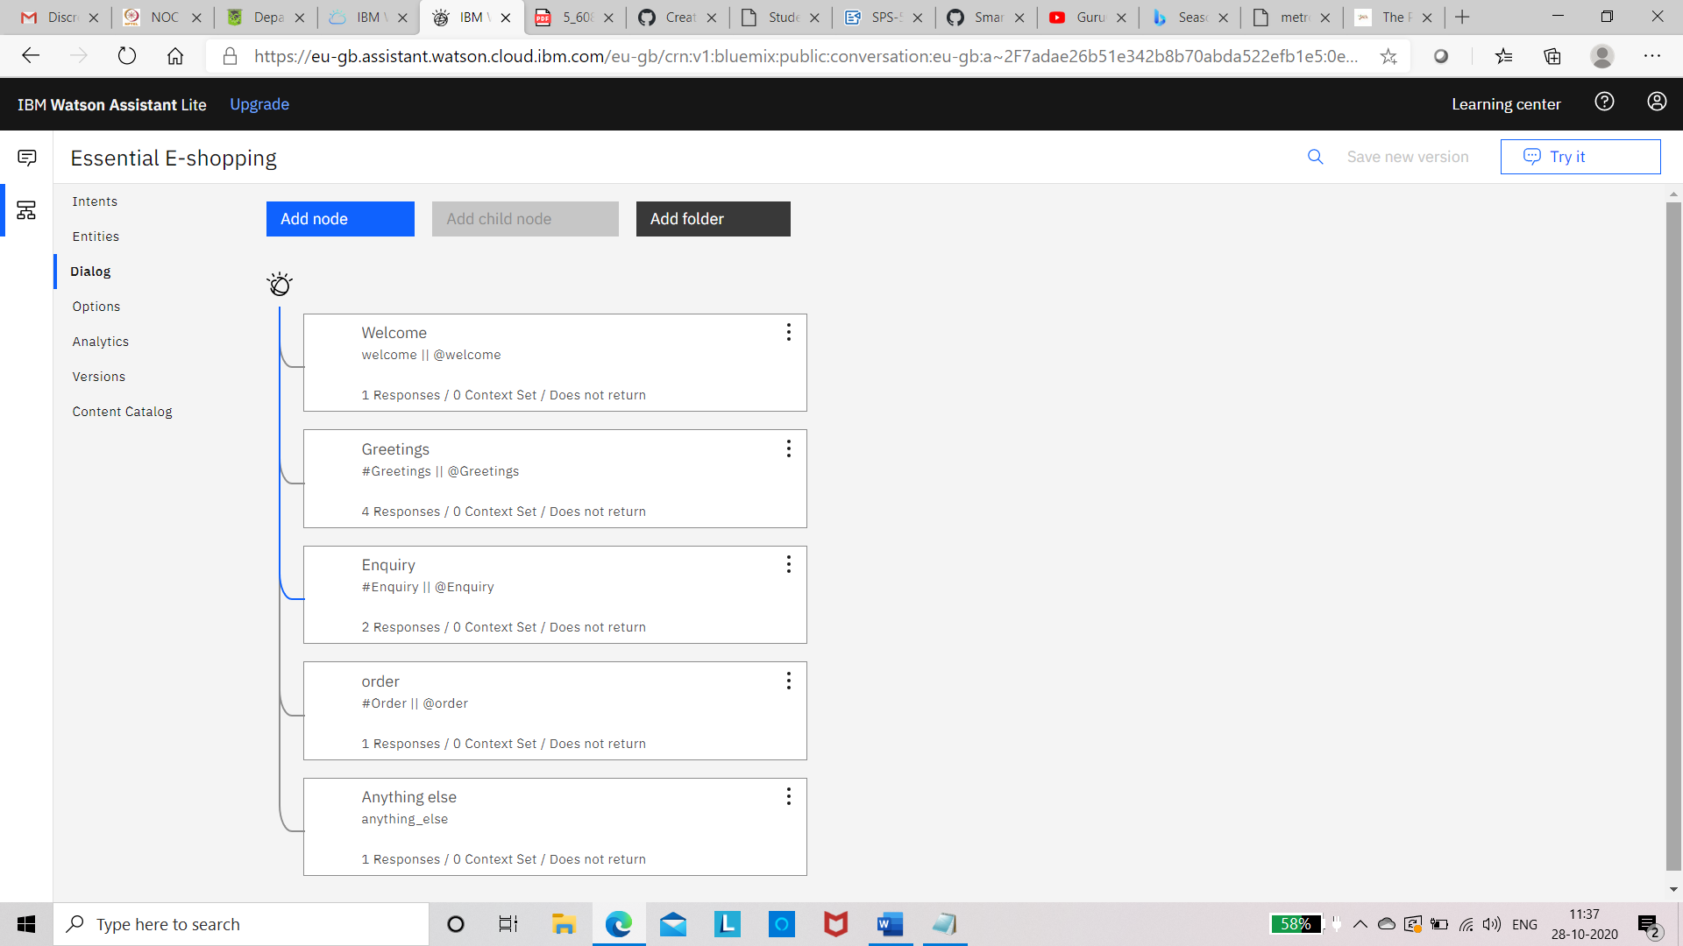

System entities

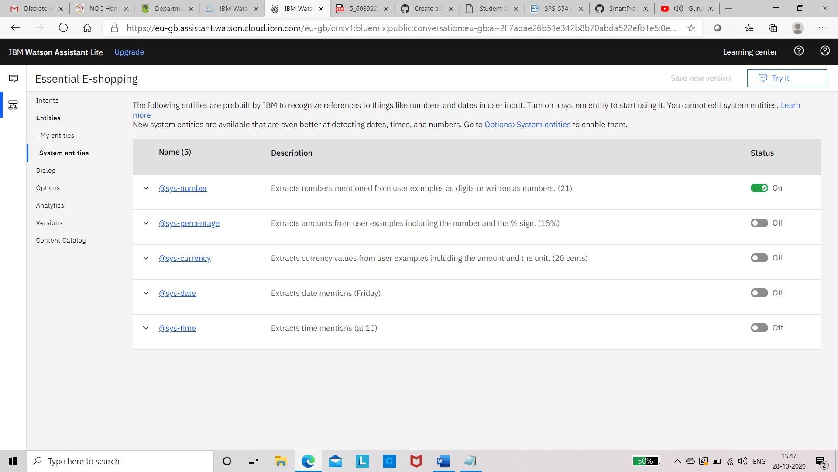

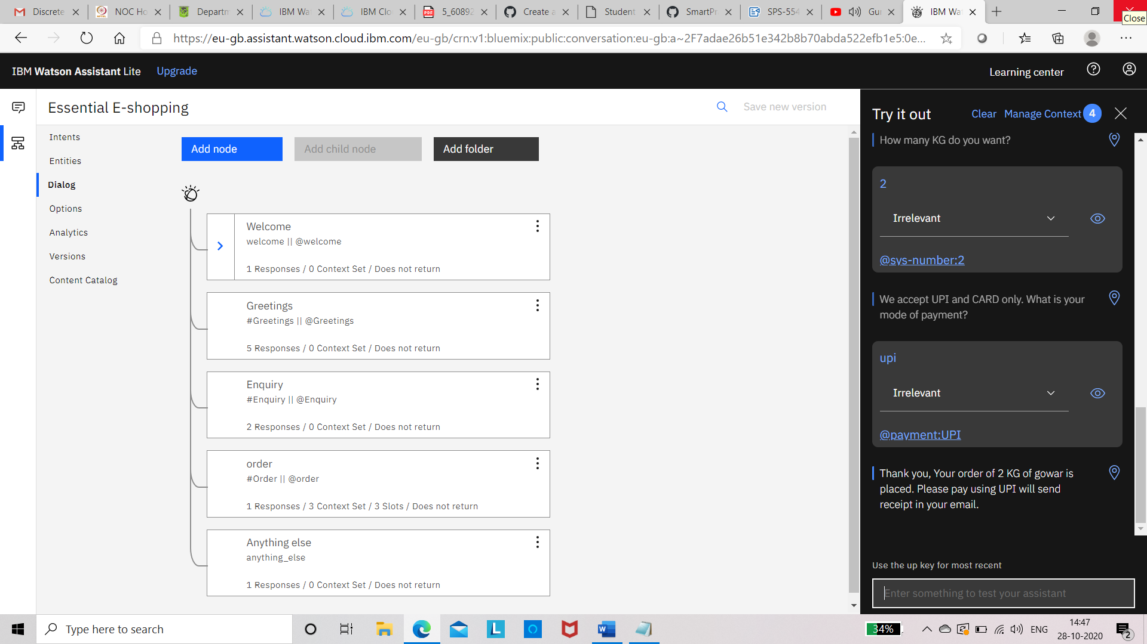

Creation of preview Link

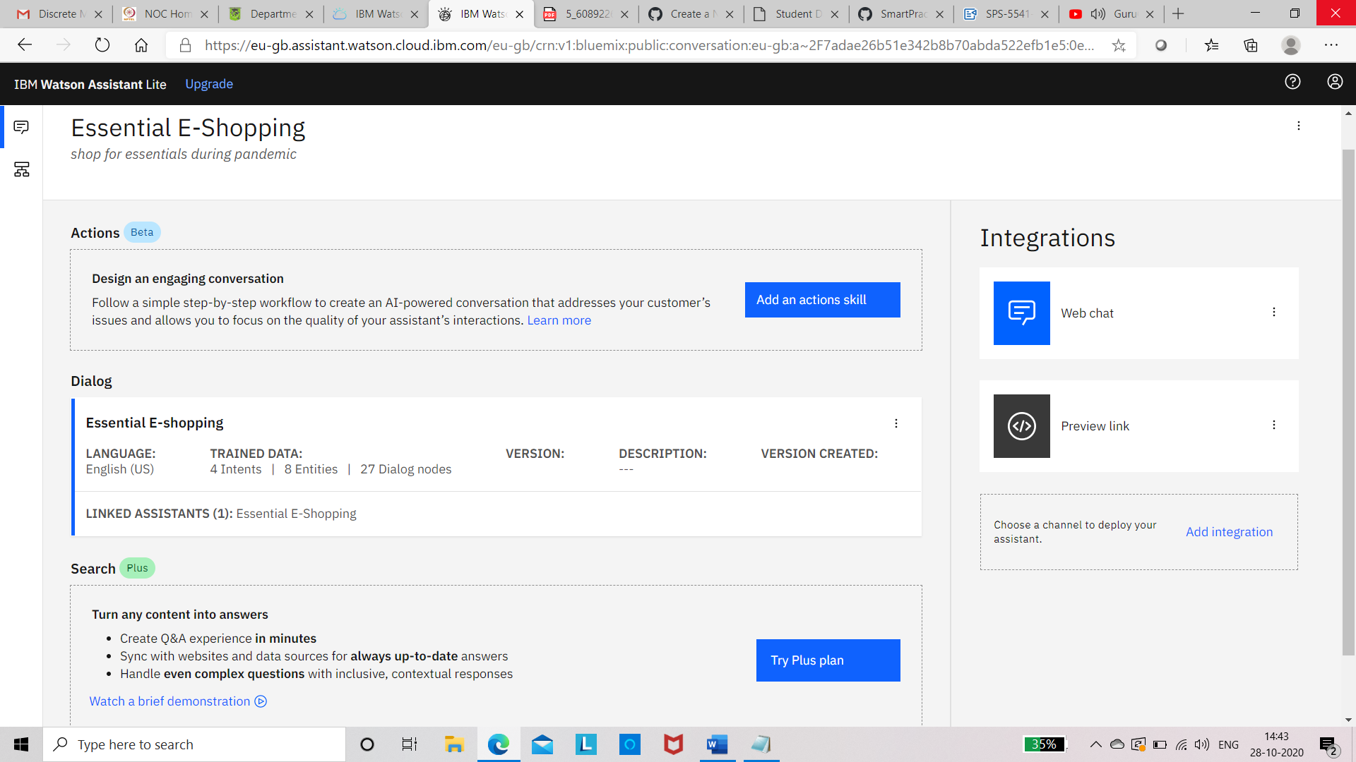

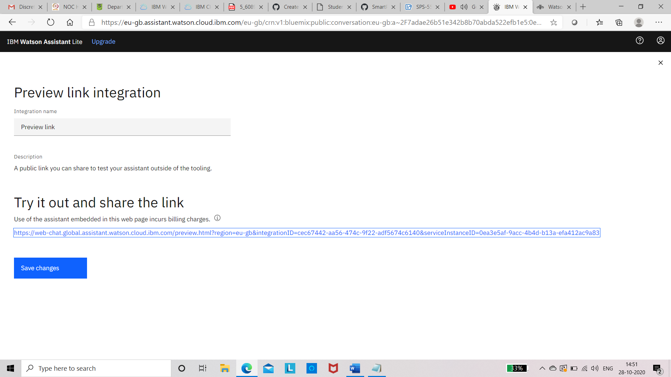

Result screen shots

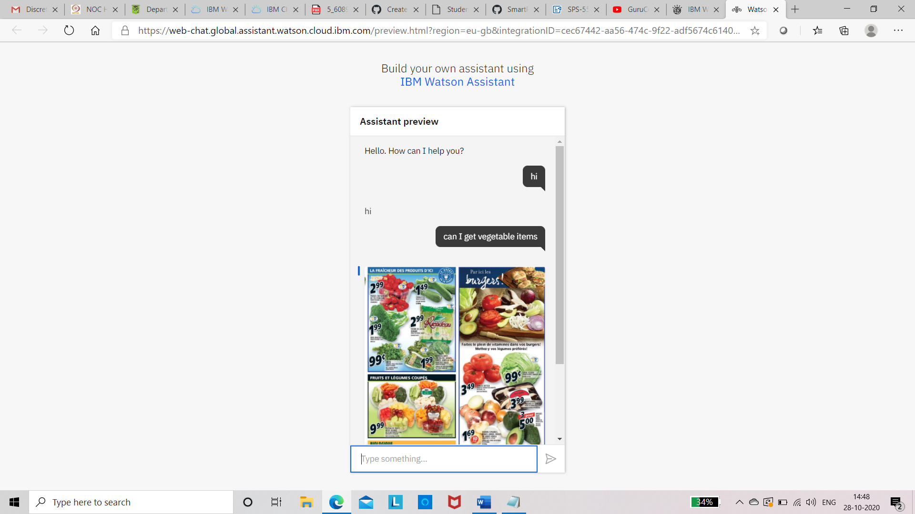

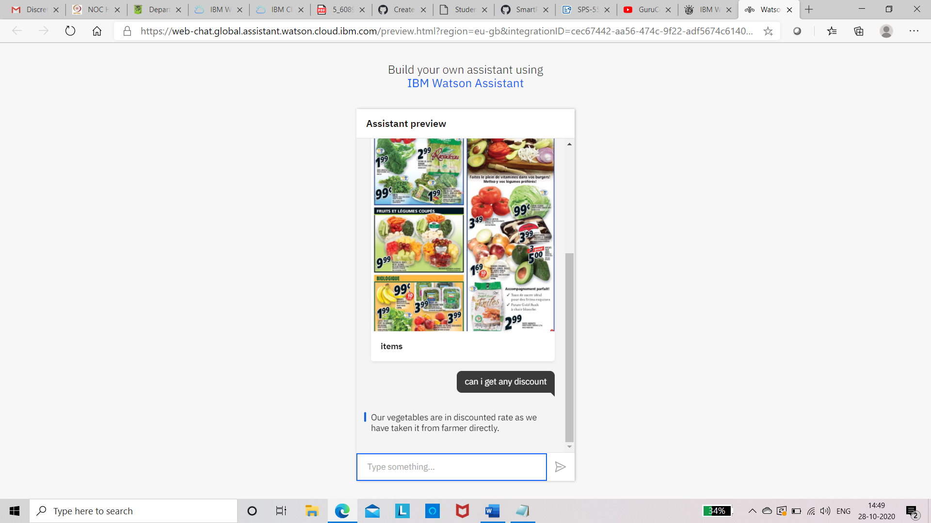 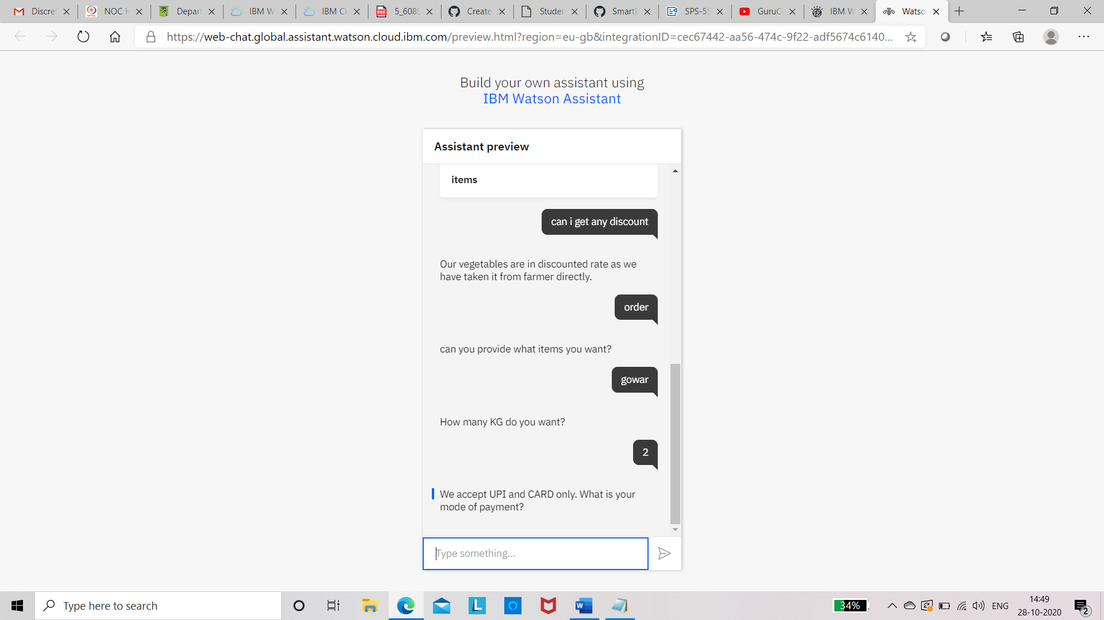 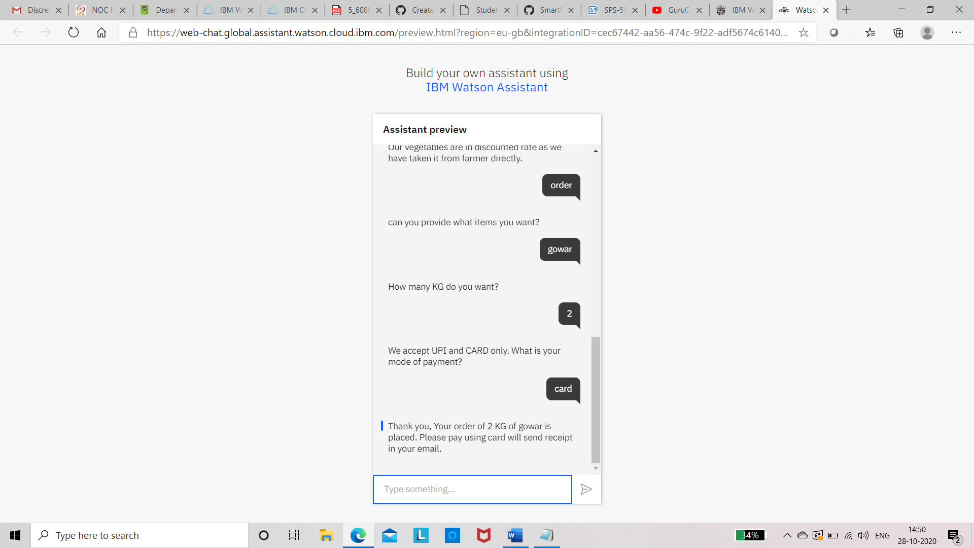

Integration with Node-red

